МИНИСТЕРСТВО ОБРАЗОВАНИЯ РЕСПУБЛИКИ БЕЛАРУСЬ

УЧРЕЖДЕНИЕ ОБРАЗОВАНИЯ

 «БРЕСТСКИЙ ГОСУДАРСТВЕННЫЙ ТЕХНИЧЕСКИЙ УНИВЕРСИТЕТ»

Кафедра ИИТ

ЛАБОРАТОРНАЯ РАБОТА №4

По дисциплине: «ОСИСП»

Выполнил:

Студент ФЭИС

3-го курса, группы ПО-5

Брич М.Н.

Проверила:

Дряпко А.В.

Брест 2021

**Цель работы:** ознакомиться с возможностями, предлагаемыми Qt для поддержки сетевого взаимодействия

программ

Вариант 3

*Задание:*

Клиентская часть осуществляет соединение с сервером и проверку обновлений для приложения.

При наличии обновлений, все необходимые файлы загружаются и копируются в директорию с

целевым приложением. В противном случае выдается соответствующее сообщение. Обработать

возможные исключительные ситуации (отсутствие соединения с сервером).  
***snake.h:***

#ifndef MAINWINDOW_H

#define MAINWINDOW_H

#include <QMainWindow>

#include <QPaintEvent>

#include <QKeyEvent>

#include <QDialog>

#include <QComboBox>

#include "interface.h"

const int BLOCK_SIZE=15;

const int MARGIN=22;

const int AREA_ROW=30;

const int AREA_COL=30;

const int TIME_INTERVAL=100;

enum Direction

{

UP,

DOWN,

LEFT,

RIGHT

};

QT_BEGIN_NAMESPACE

namespace Ui { class MainWindow; }

QT_END_NAMESPACE

class MainWindow : public QMainWindow

{

Q_OBJECT

public:

MainWindow(QWidget *parent = nullptr);

~MainWindow();

virtual void paintEvent(QPaintEvent *event);

virtual void keyPressEvent(QKeyEvent *event);

QDialog dlg;

QComboBox* modeMenu = new QComboBox;

public:

void InitMenu();

void SetPlugins();

void InitGame();

void InitPause();

void PauseResumeGame();

void GameOver();

void GenerateFood();

void GenerateSnake();

bool IsGameOver();

private slots:

void SnakeUpdate();

void aboutQt();

void applyPlugin(int index);

void BtnDlgClick1();

void BtnDlgClick2();

void BtnDlgClick3();

void LoadingLevel();

void CheckUpdate();

private:

Ui::MainWindow*ui;

QTimer *gameTimer;

bool isPause;

QPoint foodPoint;

QList<QPoint> wall;

QList<QPoint> snake;

Direction dir;

int score;

int level;

QVector< Interface* > mPlugins;

};

#endif // MAINWINDOW_H

***menu.cpp:***

#include <QPainter>

#include <time.h>

#include <QTimer>

#include <QString>

#include <QtWidgets>

#include <QMessageBox>

#include "snake.h"

#include "ui_snake.h"

typedef void (*about)();

typedef bool (*GenerateWall)(int level, int i, int j);

typedef int (*countLevel)();

void MainWindow::SetPlugins()

{

QDir *dir;

#ifdef QT_DEBUG

dir = new QDir("/home/eve9te/bstu/osisp2.0/Snake/plugins/debug");

#else

#ifdef QT_RELEASE

dir = new QDir("/home/eve9te/bstu/osisp2.0/Snake/plugins/release");

#endif

#endif

if(dir->entryList(QDir::Files).isEmpty())

qDebug() << "dir isEmpty";

foreach(QString str, dir->entryList(QDir::Files))

{

QPluginLoader loader(dir->absoluteFilePath(str));

QObject *object = qobject_cast<QObject*>(loader.instance());//извлекаем плагин

Interface *plugin = qobject_cast<Interface*>(object);//приводим к интерфейсу игры

if(plugin)

{

this->mPlugins.push_back(plugin);

// const char * namePlugin = plugin->pluginName().toLocal8Bit().data();

// QAction *applyPlugin = new QAction(tr(namePlugin), this);

modeMenu->addItem(plugin->pluginName());

connect(modeMenu, SIGNAL(activated(int)), this, SLOT(applyPlugin(int)));

}

else

{

qDebug() << "error";

}

}

delete dir;

}

void MainWindow::applyPlugin(int index)

{

QFont palette = this->mPlugins[index]->changeView();

QApplication::setFont(palette);

}

void MainWindow::InitMenu()

{

dlg.setWindowTitle(tr("Выбирите уровень"));

dlg.setFixedSize(QSize(MARGIN*7+(AREA_COL+1)*BLOCK_SIZE,MARGIN*2+AREA_ROW*BLOCK_SIZE));

dlg.setGeometry(

QStyle::alignedRect(

Qt::LeftToRight,

Qt::AlignCenter,

dlg.size(),

QApplication::desktop()->availableGeometry(this)

)

);

QBoxLayout* layout = new QVBoxLayout;

layout->setAlignment(Qt::AlignVCenter);

QMenuBar* menuBar = new QMenuBar();

QMenu* menu = new QMenu("О программе");

menuBar->addMenu(menu);

menu->addAction("about.dll", this,SLOT(aboutQt()),

Qt::CTRL + Qt::Key_Q);

layout->setMenuBar(menuBar);

QPushButton* btn_easy = new QPushButton("Easy");

QPushButton* btn_medium = new QPushButton("Medium");

QPushButton* btn_hard = new QPushButton("Hard");

QPushButton* btn_update = new QPushButton("Update");

btn_update->setContentsMargins(QMargins(0,30,0,0));

QPushButton* btn_exit = new QPushButton("Exit");

// btn_exit->setStyleSheet("margin-top: 5px;"

// "padding-top: 3px; padding-bottom: 3px;");

connect(btn_easy, SIGNAL(clicked()), this, SLOT(BtnDlgClick1()));

connect(btn_medium, SIGNAL(clicked()), this, SLOT(BtnDlgClick2()));

connect(btn_hard, SIGNAL(clicked()), this, SLOT(BtnDlgClick3()));

connect(btn_update, SIGNAL(clicked()), this, SLOT(CheckUpdate()));

connect(btn_exit, SIGNAL(clicked()), &dlg, SLOT(close()));

layout->addWidget(btn_easy);

layout->addWidget(btn_medium);

layout->addWidget(btn_hard);

layout->addWidget(btn_update);

layout->addWidget(btn_exit);

layout->addWidget(modeMenu);

dlg.setLayout(layout);

if(dlg.exec() == QDialog::Accepted) {

InitGame();

}

else

{

exit(0);

}

}

void MainWindow::BtnDlgClick1()

{

level = 1;

LoadingLevel();

}

void MainWindow::BtnDlgClick2()

{

level = 2;

LoadingLevel();

}

void MainWindow::BtnDlgClick3()

{

level = 3;

LoadingLevel();

}

void MainWindow::LoadingLevel()

{

QLibrary *helperLib = new QLibrary("helper");

if (!helperLib->load())

qDebug() << helperLib->errorString();

if (helperLib->load())

qDebug() << "library loaded";

countLevel countLevel_ = (countLevel) helperLib->resolve("countLevel");

if(level > countLevel_())

{

QMessageBox msgBox;

msgBox.setWindowTitle("Error");

msgBox.setText("Уровень еще не добавлен");

msgBox.exec();

return;

}

GenerateWall generateWall_ = (GenerateWall)helperLib->resolve("GenerateWall");

for (int i = 0; i < AREA_COL; ++i) {

for (int j = 0; j < AREA_ROW; ++j) {

if(generateWall_(level, i, j)){

wall.push_back(QPoint(i, j));

}

}

}

delete helperLib;

dlg.accept();

}

void MainWindow::CheckUpdate()

{

QMessageBox msgBox;

msgBox.setWindowTitle("Update");

msgBox.setText("This is latest version");

msgBox.exec();

}

void MainWindow::aboutQt()

{

QLibrary *aboutLib = new QLibrary("about");

if (!aboutLib->load())

qDebug() << aboutLib->errorString();

if (aboutLib->load())

qDebug() << "library loaded";

about showWindowAboutProgramm = (about)aboutLib->resolve("about");

showWindowAboutProgramm();

delete aboutLib;

}

MainWindow::~MainWindow()

{

delete ui;

}

***snake.cpp***

#include "snake.h"

#include "ui_snake.h"

Snake::Snake(QWidget *parent): QMainWindow(parent), ui(new Ui::Snake)

{

typedef QString (*Helper_set_name_window)();

typedef QString (*Helper_set_name_about)();

ui->setupUi(this);

setFixedSize(QSize(MARGIN*7+(AREA_COL+1)*BLOCK_SIZE,MARGIN*2+AREA_ROW*BLOCK_SIZE));

SetPlugins();

Setlevels();

// установка имени окна приложения

QLibrary *helper_set = new QLibrary("Helper");

Helper_set_name_window set_window_name_ = (Helper_set_name_window)helper_set->resolve("set_window_name");

QString windowTitle = set_window_name_();

delete helper_set;

this->setWindowTitle(windowTitle);

// установка имени About

QLibrary *helper_set_n_about = new QLibrary("Helper");

Helper_set_name_about set_window_name_first = (Helper_set_name_about)helper_set_n_about->resolve("set_name_About");

QMenu* menu = new QMenu(set_window_name_first());

delete helper_set_n_about;

ui->menubar->addMenu(menu);

menu->addAction("about.dll", this,SLOT(aboutQt()), Qt::CTRL + Qt::Key_Q);

}

void Snake::InitMenu() {

typedef QString (*Helper_set_name_window)();

typedef QString (*Helper_set_name_about)();

ui->setupUi(this);

levels.clear();

setFixedSize(QSize(MARGIN*7+(AREA_COL+1)*BLOCK_SIZE,MARGIN*2+AREA_ROW*BLOCK_SIZE));

connect(ui->levelslist, SIGNAL(currentIndexChanged(const QString)), this, SLOT(on_levelslist_currentIndexChanged(QString)));

connect(ui->btn_start, SIGNAL(clicked()), this, SLOT(on_btn_start_clicked()));

connect(ui->btn_update, SIGNAL(clicked()), this, SLOT(on_btn_update_clicked()));

connect(ui->btn_exit, SIGNAL(clicked()), this, SLOT(on_btn_exit_clicked()));

SetPlugins();

Setlevels();

// установка имени окна приложения

QLibrary *helper_set = new QLibrary("Helper");

Helper_set_name_window set_window_name_ = (Helper_set_name_window)helper_set->resolve("set_window_name");

QString windowTitle = set_window_name_();

delete helper_set;

this->setWindowTitle(windowTitle);

// установка имени About

QLibrary *helper_set_n_about = new QLibrary("Helper");

Helper_set_name_about set_window_name_first = (Helper_set_name_about)helper_set_n_about->resolve("set_name_About");

QMenu* menu = new QMenu(set_window_name_first());

delete helper_set_n_about;

ui->menubar->addMenu(menu);

menu->addAction("about.dll", this, SLOT(aboutQt()), Qt::CTRL + Qt::Key_Q);

}

void Snake::PauseResumeGame()

{

if(!isPause)

{

isPause=!isPause;

gameTimer->stop();

InitPause();

}

else

{

isPause=!isPause;

gameTimer->start(TIME_INTERVAL);

}

}

void Snake::InitPause()

{

QMessageBox::StandardButton pause;

pause = QMessageBox::question(this, "Pause", "Продолжить?",

QMessageBox::Yes|QMessageBox::No);

if (pause == QMessageBox::Yes) {

PauseResumeGame();

}

else {

flag_game = false;

InitMenu();

}

}

void Snake::GameOver()

{

gameTimer->stop();

snake.pop_front();

QMessageBox::StandardButton toMain;

toMain = QMessageBox::question(this,"Failed","Game over!", QMessageBox::Ok|QMessageBox::Ok);

if(toMain == QMessageBox::Ok) {

flag_game = false;

InitMenu();

}

}

void Snake::sockDisc() {

socket->disconnected();

}

void Snake::sockReady() {

if(socket->waitForConnected(100)) {

socket->waitForReadyRead(100);

Data = socket->readAll();

QDir dir_client(QDir::currentPath() + "/level");

if(Data == "Actuale") {

QMessageBox::information(this, "Информация", "Соединение установлено\nУ вас актуальная версия программы!");

socket->disconnected();

}

else if(Data == "Need update") {

Data.clear();

QStringList find_filter;

bool ok = dir_client.exists();

if (ok) {

dir_client.setFilter(QDir::Files | QDir::Hidden | QDir::NoSymLinks);

dir_client.setSorting(QDir::Name);

QFileInfoList list = dir_client.entryInfoList();

for (int i = 0; i < list.size(); ++i) {

QFileInfo fileInfo = list.at(i);

find_filter.append(fileInfo.fileName());

}

qDebug() << find_filter << endl;

}

foreach (const QString &str, find_filter) {

Data.append(str);

if(&str != find_filter.last()) {

Data.append(" ");

}

}

qDebug() << Data << endl;

socket->write(Data);

socket->waitForBytesWritten(100);

}

else {

QStringList rec_data_update;

QString new_version;

rec_data_update.append(QString(Data).split(" "));

new_version.append(rec_data_update.last());

QDir new_client_version(qApp->applicationDirPath());

QStringList filter;

filter << "*.json";

foreach(QFileInfo info, new_client_version.entryInfoList(filter)) {

filter.clear();

filter << info.absoluteFilePath();

}

QFile file(filter.back());

if (!file.open(QIODevice::WriteOnly))

return;

file.write(new_version.toStdString().data());

for(int i = 1; i < rec_data_update.size()-1; i++) {

QFile::copy(rec_data_update.front()+'/'+rec_data_update[i], dir_client.path()+'/'+rec_data_update[i]);

}

levels.clear();

ui->levelslist->clear();

Setlevels();

QMessageBox::information(this, "Информация", "Обновление завершено!");

//create log

QDir write_log(QDir::currentPath() + "/logs");

QStringList formatFile;

formatFile << "*.txt";

foreach(QFileInfo info, write_log.entryInfoList(formatFile)) {

formatFile.clear();

formatFile << info.absoluteFilePath();

}

QFile log(formatFile.front());

if (!log.open(QIODevice::WriteOnly))

return;

QString text = "Update Modules and version "+ rec_data_update.back();

log.write(text.toStdString().data());

}

}

}

void Snake::on_btn_start_clicked()

{

wall.clear();

typedef bool (*GenerateWall)(int i, int j);

QLibrary *loadLevel = new QLibrary("./level/"+level);

GenerateWall generateWall_ = (GenerateWall)loadLevel->resolve("GenerateWall");

for (int i = 0; i < AREA_COL; ++i) {

for (int j = 0; j < AREA_ROW; ++j) {

if(generateWall_(i, j)){

wall.push_back(QPoint(i, j));

}

}

}

ui->centralwidget->setVisible(false);

flag_game = true;

InitGame();

delete loadLevel;

}

void Snake::on_levelslist_currentIndexChanged(const QString &arg1)

{

level = arg1;

}

***game.cpp***

#include <QPainter>

#include <time.h>

#include <QTimer>

#include <QString>

#include <QtWidgets>

#include <QMessageBox>

#include "snake.h"

#include "ui_snake.h"

typedef bool (*Generate_Snake)(int i);

void MainWindow::InitGame()

{

snake.clear();

GenerateSnake();

dir=RIGHT;

srand(time(0));

GenerateFood();

score=0;

isPause=false;

gameTimer=new QTimer(this);

connect(gameTimer, SIGNAL(timeout()), this, SLOT(SnakeUpdate()));

gameTimer->start(TIME_INTERVAL);

}

void MainWindow::GenerateSnake()

{

QLibrary *helperLib = new QLibrary("helper");

if (!helperLib->load())

qDebug() << helperLib->errorString();

if (helperLib->load())

qDebug() << "library loaded";

Generate_Snake generateSnake_ = (Generate_Snake)helperLib->resolve("GenerateSnake");

for (int i=AREA_COL;i>=0;i--) {

if(generateSnake_(i)){

snake.push_back(QPoint(i, 0));

}

}

delete helperLib;

}

void MainWindow::paintEvent(QPaintEvent *event)

{

Q_UNUSED(event);

QPainter painter(this);

painter.setBrush(Qt::yellow);

painter.setPen(Qt::blue);

painter.drawRect(MARGIN,MARGIN,AREA_COL*BLOCK_SIZE,AREA_ROW*BLOCK_SIZE);

painter.setBrush(Qt::blue);

painter.setPen(Qt::black);

for(int i=0;i<wall.size();i++)

painter.drawRect(MARGIN+wall[i].x()*BLOCK_SIZE,MARGIN+wall[i].y()*BLOCK_SIZE,BLOCK_SIZE,BLOCK_SIZE);

painter.setBrush(Qt::red);

painter.setPen(Qt::green);

for(int i=0;i<snake.size();i++)

painter.drawRect(MARGIN+snake[i].x()*BLOCK_SIZE,MARGIN+snake[i].y()*BLOCK_SIZE,BLOCK_SIZE,BLOCK_SIZE);

painter.setBrush(Qt::green);

painter.drawEllipse(MARGIN+foodPoint.x()*BLOCK_SIZE,MARGIN+foodPoint.y()*BLOCK_SIZE,BLOCK_SIZE,BLOCK_SIZE);

painter.setPen(Qt::black);

painter.setFont(QFont("Arial",14));

painter.drawText(MARGIN*3+AREA_COL*BLOCK_SIZE,MARGIN+2*BLOCK_SIZE,"score: "+QString::number(score));

}

void MainWindow::keyPressEvent(QKeyEvent *event)

{

switch(event->key())

{

case Qt::Key_Up:

if(dir!=DOWN)

dir=UP;

break;

case Qt::Key_Down:

if(dir!=UP)

dir=DOWN;

break;

case Qt::Key_Left:

if(dir!=RIGHT)

dir=LEFT;

break;

case Qt::Key_Right:

if(dir!=LEFT)

dir=RIGHT;

break;

case Qt::Key_P:

PauseResumeGame();

break;

case Qt::Key_Escape:

PauseResumeGame();

break;

default:

break;

}

}

bool MainWindow::IsGameOver()

{

int x=snake.front().x();

int y=snake.front().y();

if(x<0||x>AREA_COL-1||y<0||y>AREA_ROW-1)

return true;

for(int i=1;i<snake.size();i++)

if(snake[i]==snake.front())

return true;

for(int i=0;i<wall.size();i++)

if(wall[i]==snake.front())

return true;

return false;

}

void MainWindow::SnakeUpdate()

{

switch(dir)

{

case UP:

snake.push_front(QPoint(snake.front().x(),snake.front().y()-1));

break;

case DOWN:

snake.push_front(QPoint(snake.front().x(),snake.front().y()+1));

break;

case LEFT:

snake.push_front(QPoint(snake.front().x()-1,snake.front().y()));

break;

case RIGHT:

snake.push_front(QPoint(snake.front().x()+1,snake.front().y()));

break;

default:

break;

}

if(snake.contains(foodPoint))

{

score+=1;

GenerateFood();

gameTimer->start(TIME_INTERVAL - score);

}

else

snake.pop_back();

if(IsGameOver())

{

GameOver();

return;

}

update();

}

***food.cpp***

*#include <QPainter>*

*#include <time.h>*

*#include <QTimer>*

*#include <QString>*

*#include <QtWidgets>*

*#include <QMessageBox>*

*#include "snake.h"*

*#include "ui_snake.h"*

*void MainWindow::GenerateFood()*

*{*

*foodPoint.setX(rand()%AREA_COL);*

*foodPoint.setY(rand()%AREA_ROW);*

*if(snake.contains(foodPoint) || wall.contains(foodPoint))*

*GenerateFood();*

*}*

***myserver.cpp***

*#include "myserver.h"*

*MyServer::MyServer(){}*

*MyServer::~MyServer(){}*

*void MyServer::StartServer(){*

*if(this->listen(QHostAddress::Any, 5555)) {*

*qDebug() << "Listening";*

*}*

*else {*

*qDebug() << "Not Listening";*

*}*

*}*

*void MyServer::incomingConnection(int socketDeskriptor) {*

*socket = new QTcpSocket(this);*

*socket->setSocketDescriptor(socketDeskriptor);*

*connect(socket,SIGNAL(readyRead()), this, SLOT(sockReady()));*

*connect(socket,SIGNAL(disconnected()),this,SLOT(sockDisc()));*

*qDebug()<<socketDeskriptor<<"Client connected";*

*qDebug()<<"Send client connect status - YES";*

*}*

*void MyServer::sockReady() {*

*Data = socket->readAll();*

*qDebug() << "Select from Client" << Data;*

*if(!Data.isEmpty()) {*

*QDir server_version(QDir::currentPath());*

*QStringList filter;*

*filter << "*.json";*

*foreach(QFileInfo info, server_version.entryInfoList(filter)) {*

*filter.clear();*

*filter << info.absoluteFilePath();*

*}*

*qDebug() << filter;*

*QFile file(filter.back());*

*if (!file.open(QIODevice::ReadOnly))*

*return;*

*path_to_Download = file.readAll();*

*if(QString(Data) == path_to_Download) {*

*qDebug() << "Send to Client" << "Actuale";*

*socket->write("Actuale");*

*}*

*else if(Data[0] == 'l') {*

*QStringList client_data;*

*client_data.append(QString(Data).split(" "));*

*Data.clear();*

*QDir dir_server(QDir::currentPath() + "/level");*

*QStringList find_filter;*

*Data.append(dir_server.path()+' ');*

*bool ok = dir_server.exists();*

*if (ok)*

*{*

*dir_server.setFilter(QDir::Files | QDir::Hidden | QDir::NoSymLinks);*

*dir_server.setSorting(QDir::Name);*

*QFileInfoList list = dir_server.entryInfoList();*

*for (int i = 0; i < list.size(); ++i)*

*{*

*QFileInfo fileInfo = list.at(i);*

*find_filter.append(fileInfo.fileName());*

*}*

*}*

*QStringList sen_to_clien;*

*for(int i = client_data.size(); i < find_filter.size(); i++) {*

*sen_to_clien.append(find_filter[i]);*

*}*

*foreach (const QString &str, sen_to_clien)*

*{*

*Data.append(str);*

*if(&str != find_filter.last()) {*

*Data.append(" ");*

*}*

*else {*

*Data.append(" ");*

*Data.append(path_to_Download);*

*}*

*}*

*qDebug() << "Send to Client" << Data;*

*socket->write(Data);*

*}*

*else {*

*qDebug() << "Send to Client" << "Need update";*

*socket->write("Need update");*

*}*

*socket->waitForBytesWritten(100);*

*}*

*}*

*void MyServer::sockDisc(){*

*qDebug()<<"Disconnect";*

*socket->deleteLater();*

*}*

*Тестирование:*

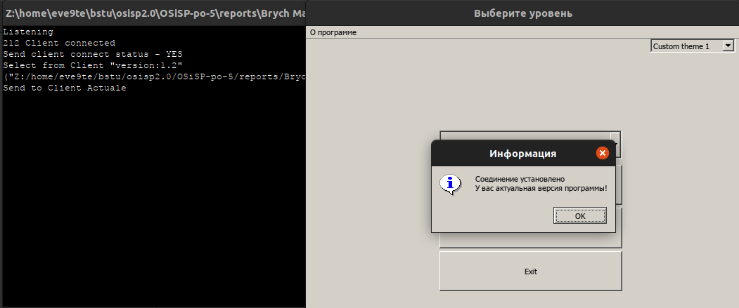

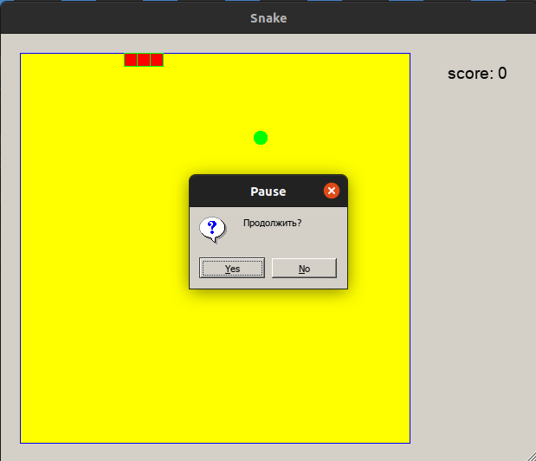

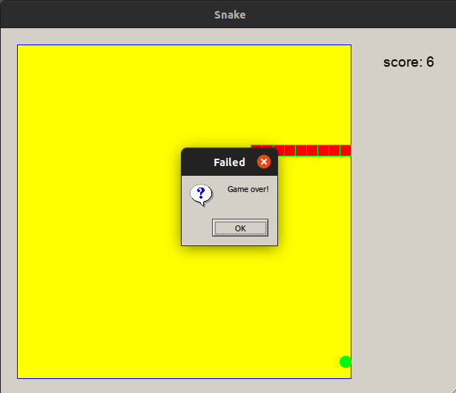

Вывод: приобрел практические навыки проектирования и разработки приложений с графическим пользовательским интерфейсом в ОС Windows средствами Qt.